 | StudyX  Installation: Demo.

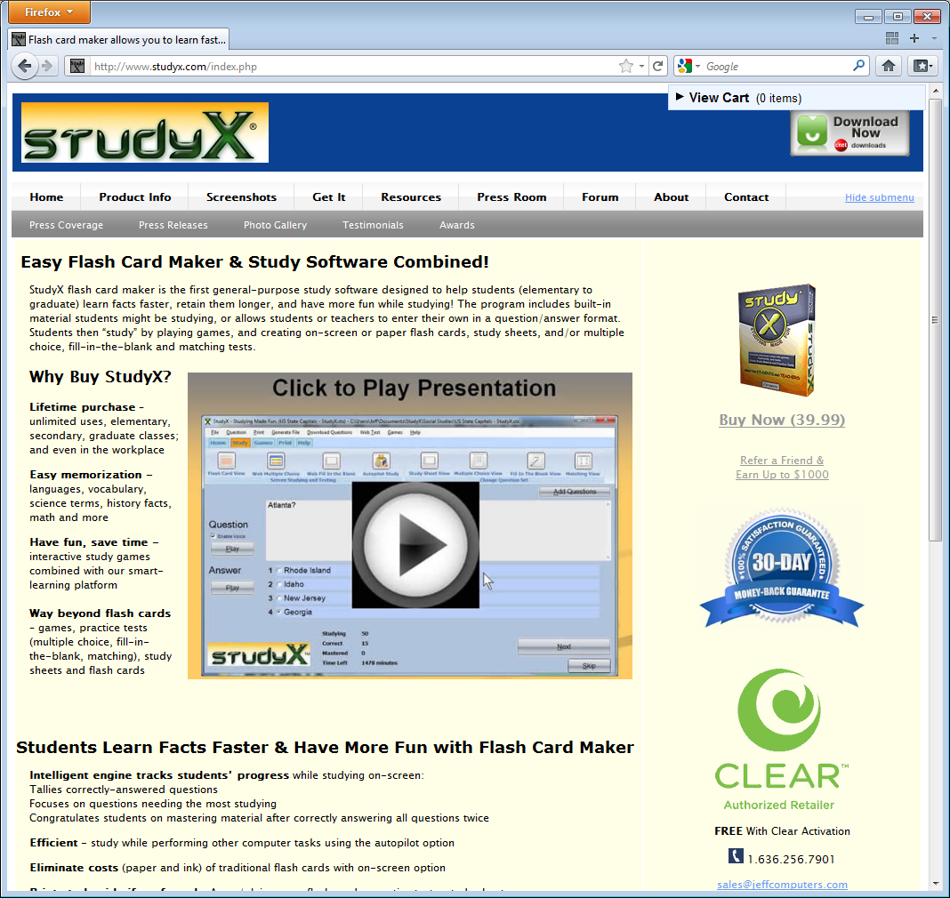 | Download StudyX from http://www.StudyX.com  By clicking the Get It button.
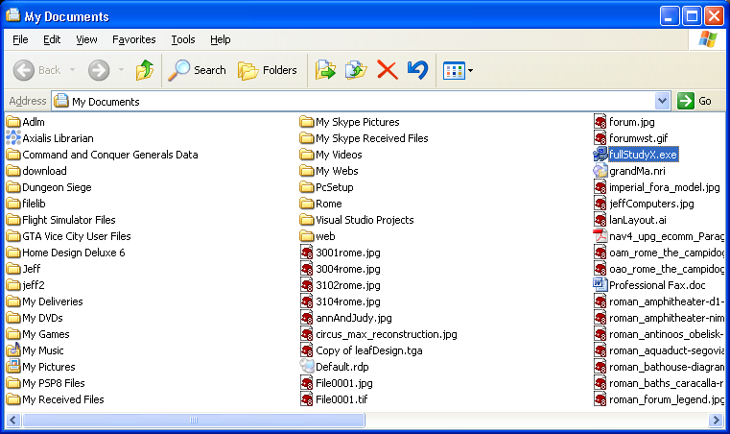 | Double click StudyX.exe that you downloaded in previous step.  (note: if double clicking does not seem to work, right click and rename to fullStudyX.exe)
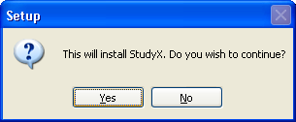 |  | Click Yes.
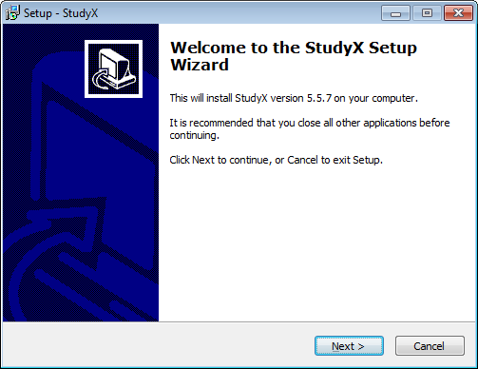 |  | Click Next
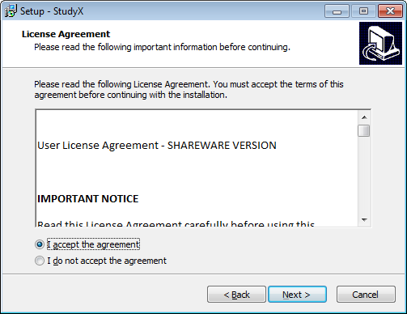 |  | Click ‘I accept the agreement’.  Click Next.
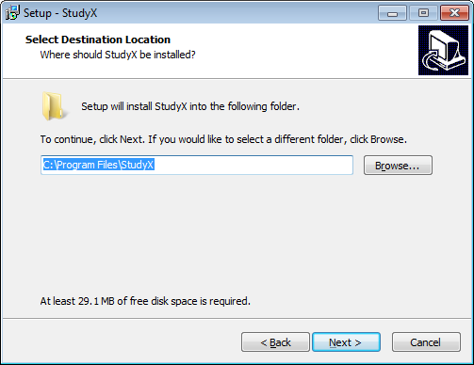 |  | Click Next.
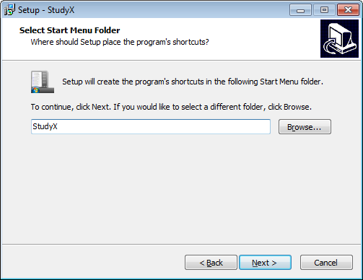 |  | Click Next.
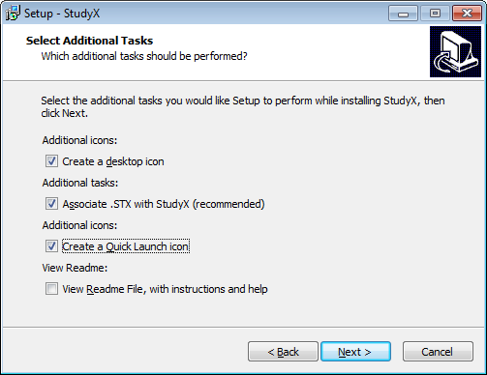 |  | Click Next.
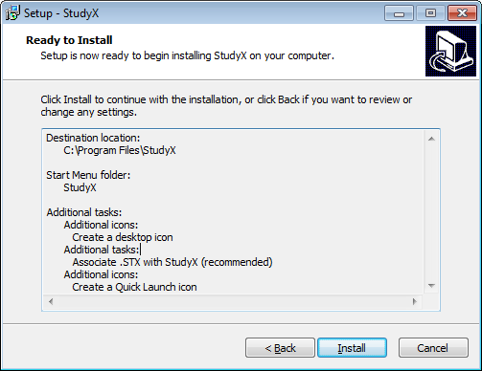 |  | Click Install.
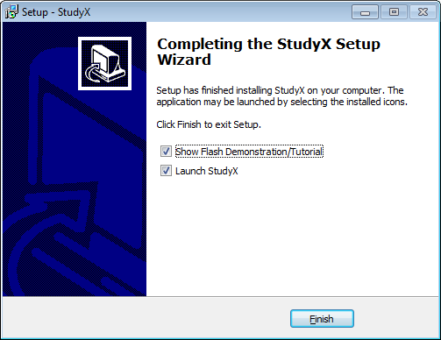 |  | Click Finish.
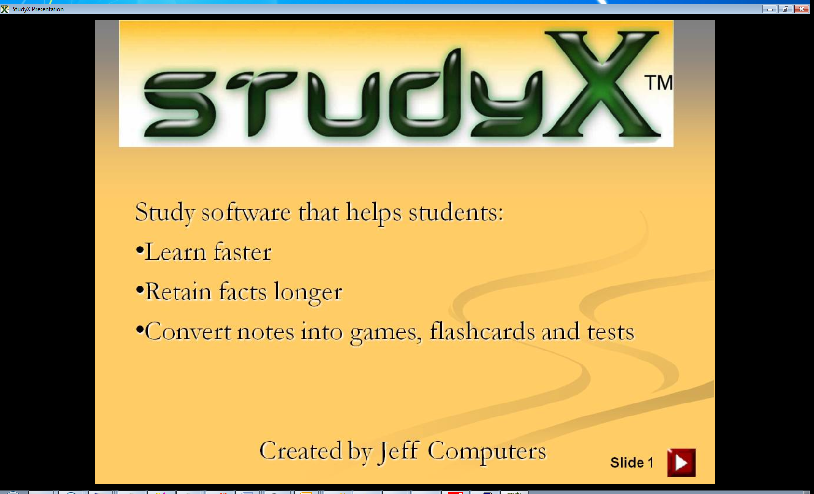 |  | Close the presentation by clicking the ‘X’ in the top right.
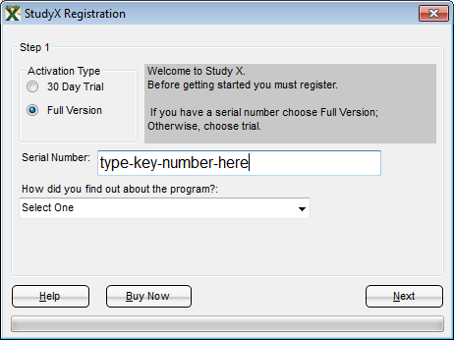 |  | For the full version, select Full Version. (for the trial, select 30 day trial)  Type the key number.  Click Next  Tip: to enter a full key if you are still in your 30 day trial, go to the Help menu in the top right and then Click ‘Enter Registration Key’.
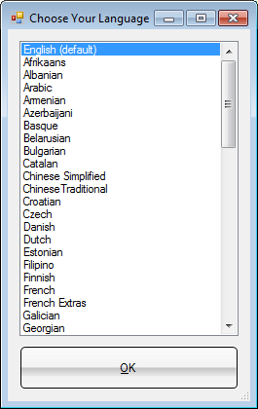 |  | Choose your native language.  Then click OK.
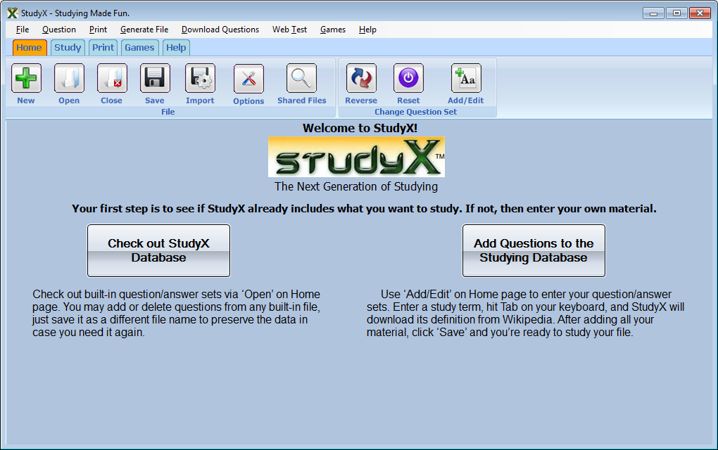 |  | Open an existing file  Or create your own.
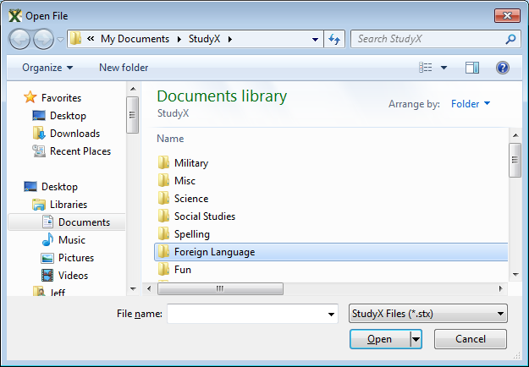 |  | Choose a subject by double clicking then double click a study file to open it.
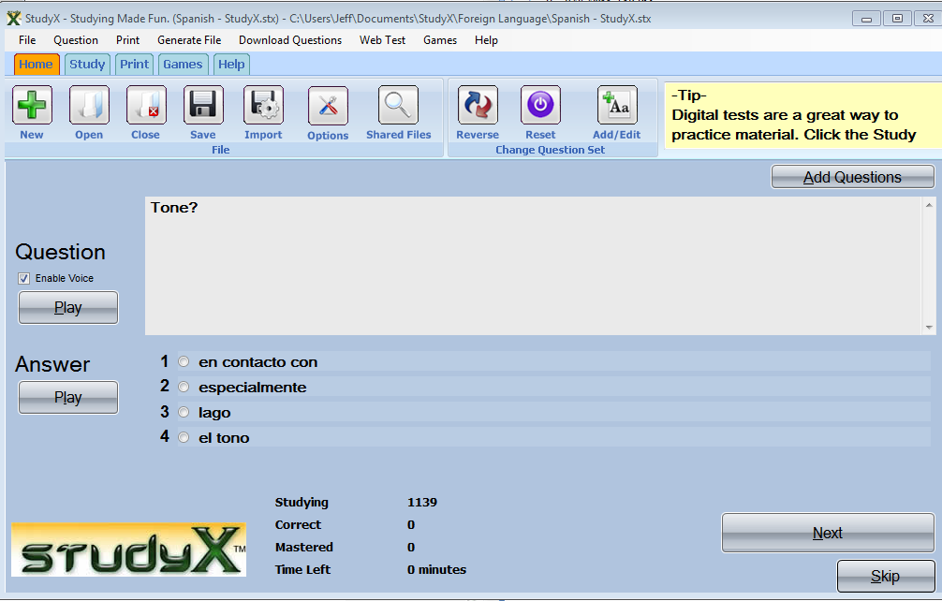 |  | Select the correct answer.  Then click Next.

Our study software had been designed to handle all of your study needs from note card/flash card printing to study games. Please email us sales@jeffcomputers.com if you have any questions. Notecards/flashcards and other tests are automatically generated by going to Print and then choosing the option. Currently there are 5 major print options.

