 | StudyX  Usage Guide

 | Load StudyX by double clicking StudyX icon on desktop.
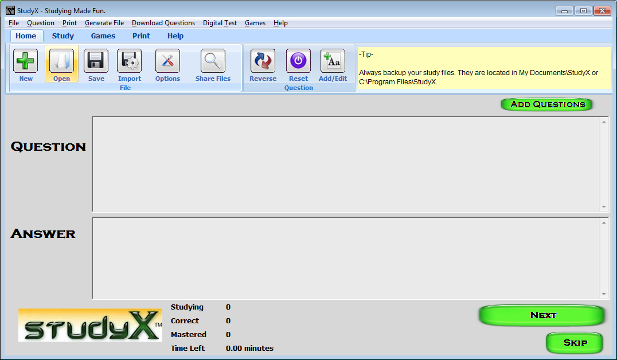 | Click the Open Button to load a file to Study  Tip: you can create your own file by clicking the add questions button.
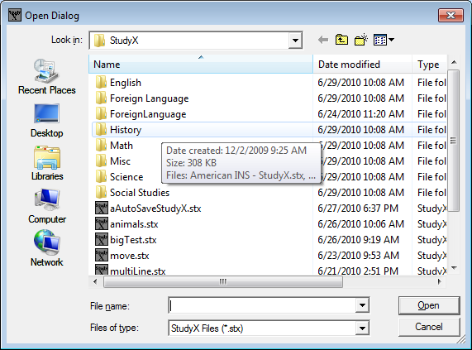 | Double click the History folder
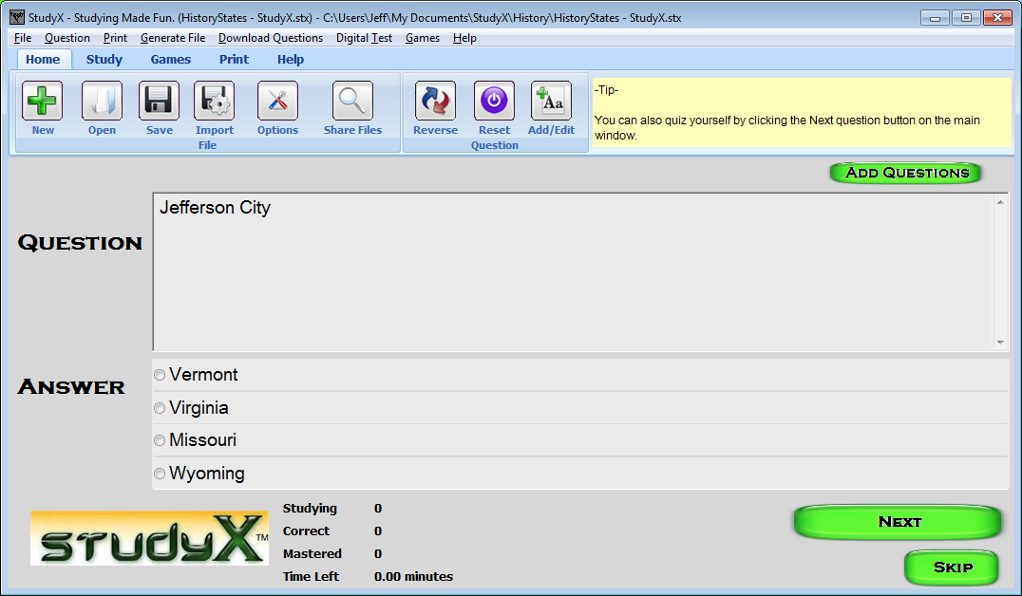 | Once done adding questions:  To Quiz:  Click an answer.  Click ‘Next’.  Repeat these 2 steps for each question.
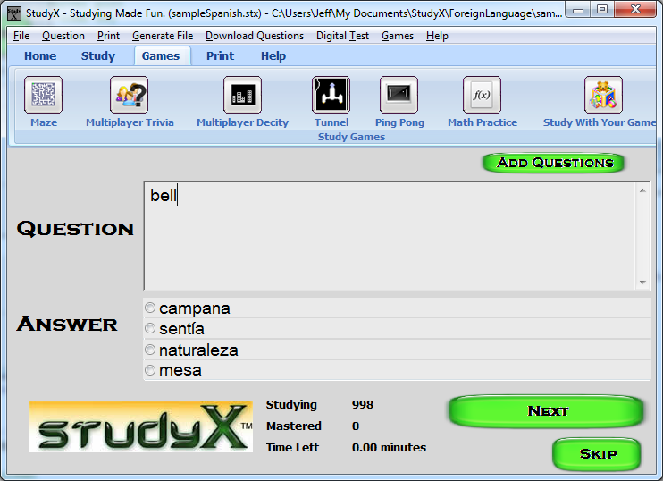 | To play a game:  Click Games tab.  Click on a game.
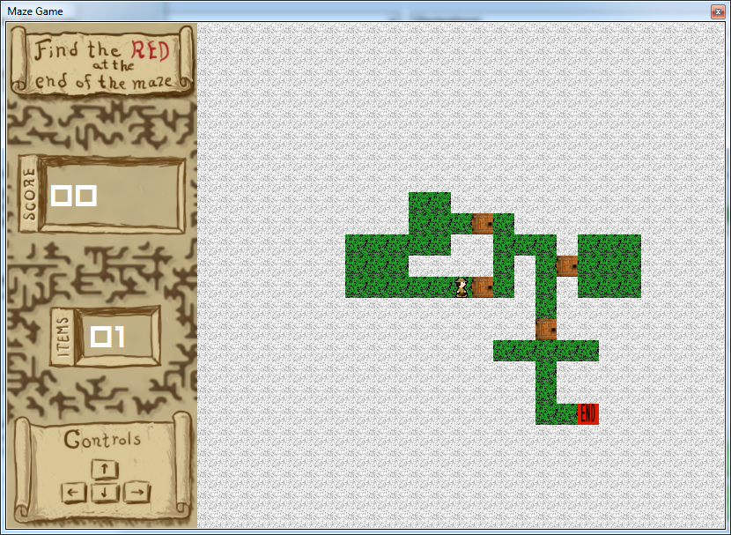 | Game should load.  View instructions at bottom.  To control:  Use arrow keys on keyboard.
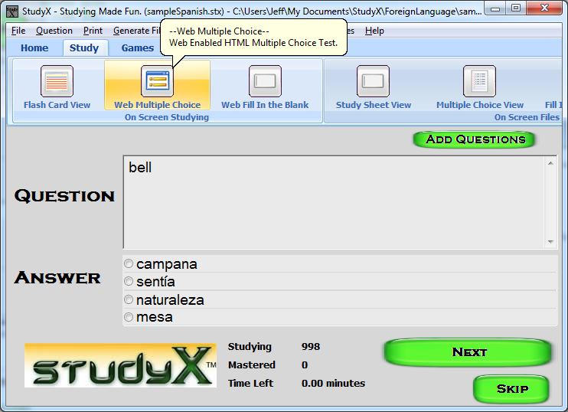 | To create a HTML digital test, from the questions:  Click Study Tab.  Click ‘Web Multiple Choice’)
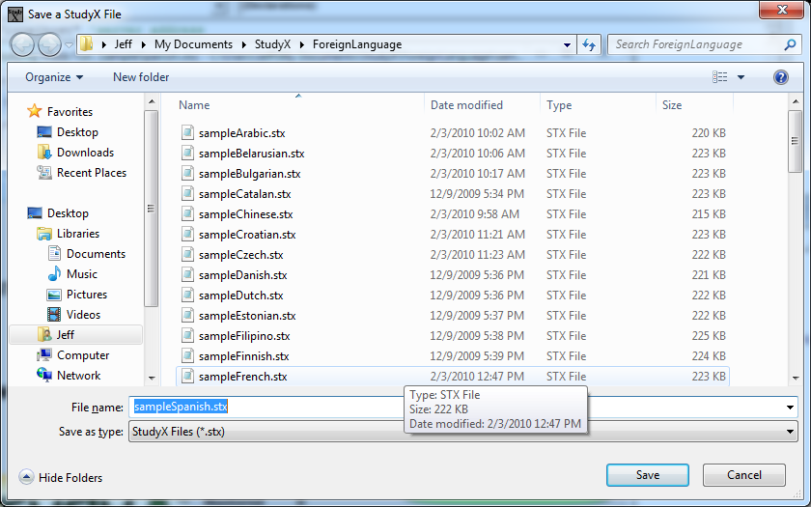 | Select location to save to.  Type File Name.  Click Save.  Your HTML document should be created. To view, just go to the file and double click.
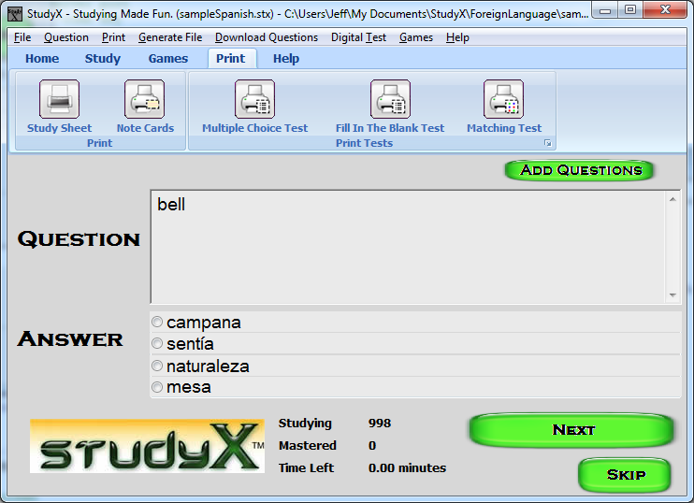 | To Print Question/Answer Sheet, and Note Cards, and Practice Tests:  Click Print  Click on desired item
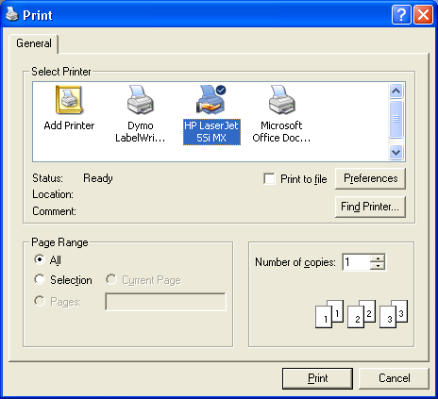 | Select Printer  Change number of Pages  Click Print
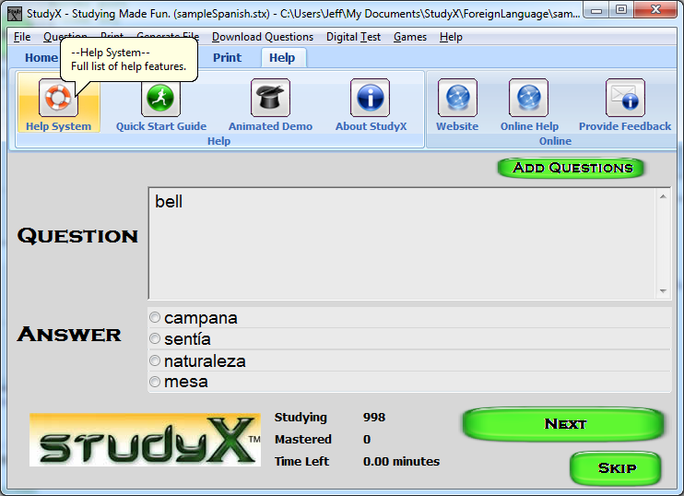 | For help in StudyX:  Click Help  Click Desired Page  Alternatively you can press F1 for more help.
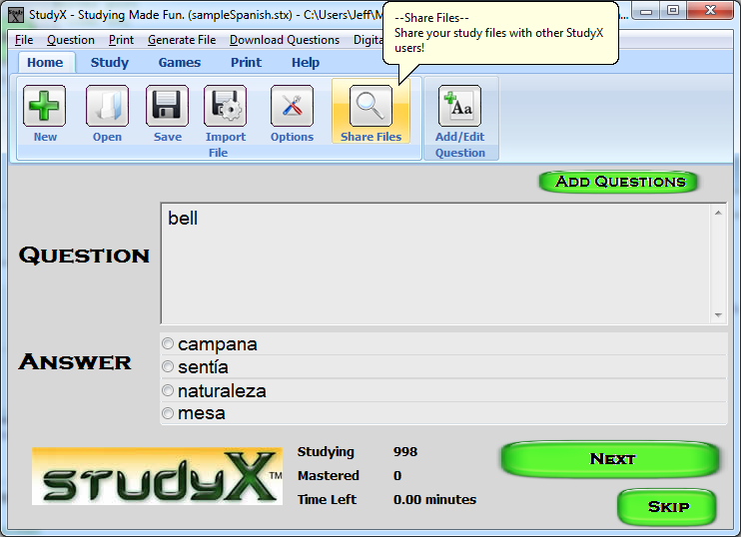 | To download/upload questions:  Click Home  Click ‘Share Files’

Our study software had been designed to handle all of your study needs from note card/flash card printing to study games. Please email us sales@jeffcomputers.com if you have any questions. Notecards/flashcards and other tests are automatically generated by going to Print and then choosing the option. Currently there are 5 major print options.

