 | StudyX  Installation/Usage: Full version.

 | Insert StudyX CD.
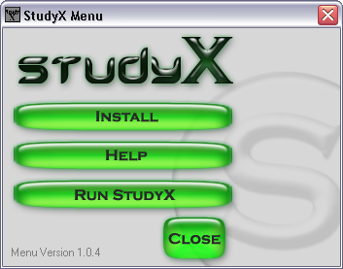 | Click Install
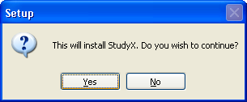 | Click Yes.
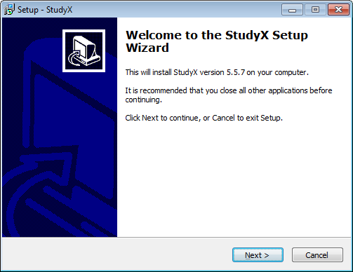 | Click Next
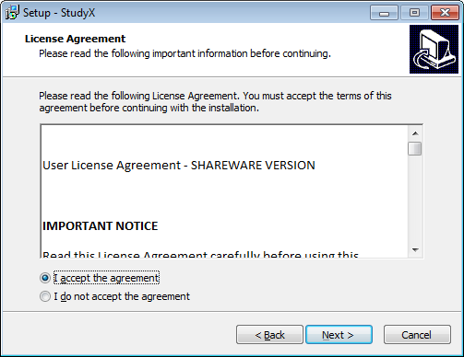 | Click ‘I accept the agreement’.  Click Next.
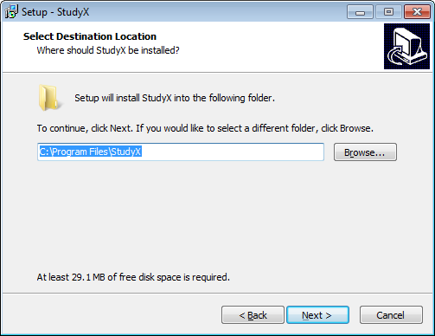 | Click Next.
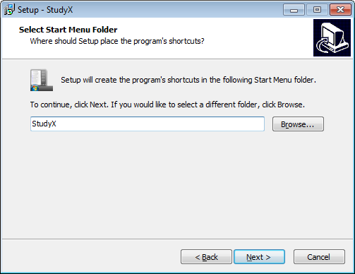 | Click Next.
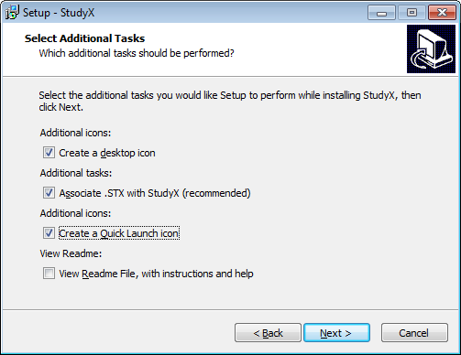 | Click Next.
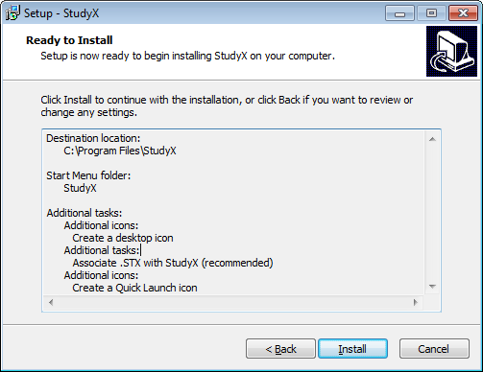 | Click Install.
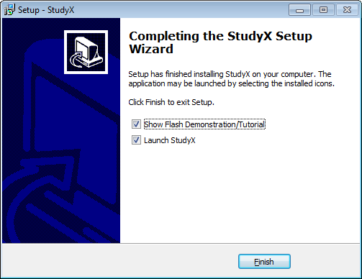 | Click Finish.
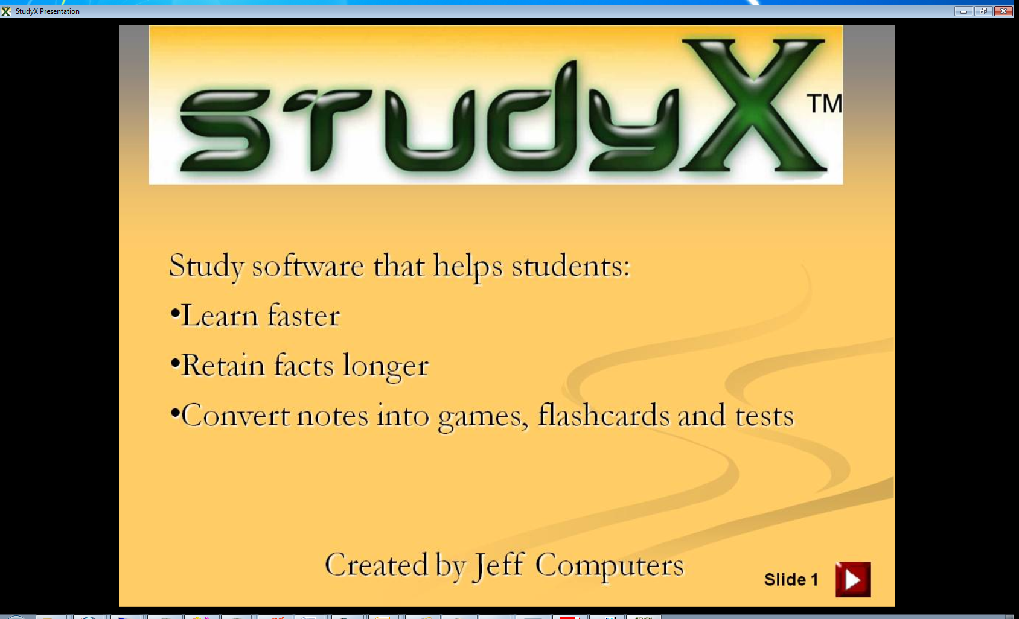 | Close the presentation by clicking the ‘X’ in the top right.
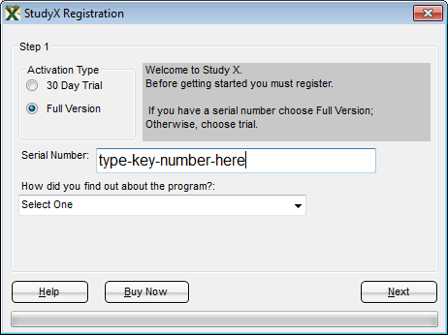 | For the full version, select Full Version. (for the trial, select 30 day trial)  Type the key number.  Click Next  Tip: to enter a full key if you are still in your 30 day trial, go to the Help menu in the top right and then Click ‘Enter Registration Key’.
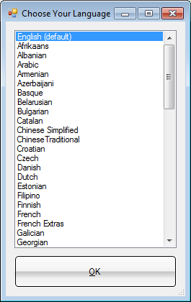 | Choose your native language.  Then click OK.
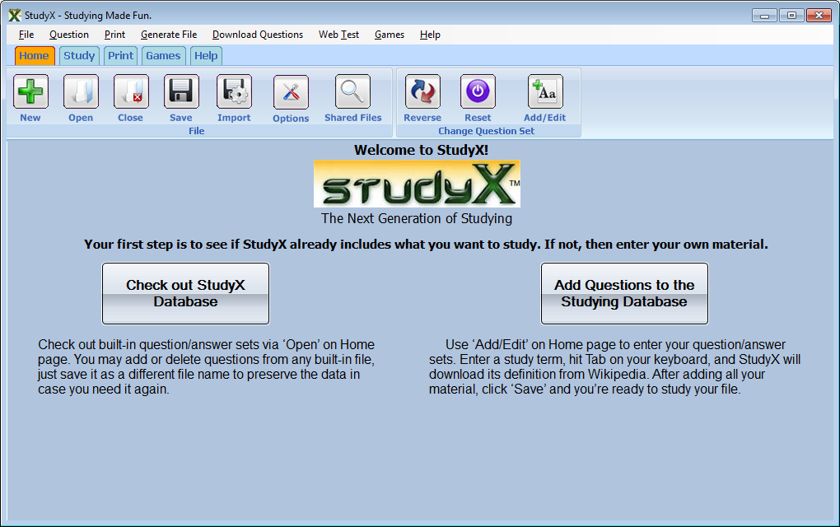 | Open an existing file  Or create your own.
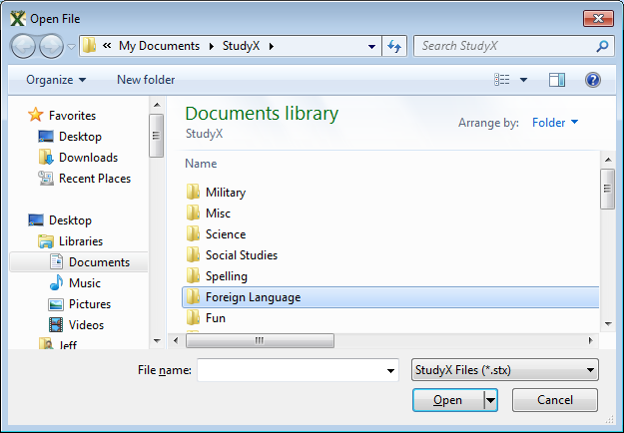 | Choose a subject by double clicking then double click a study file to open it.
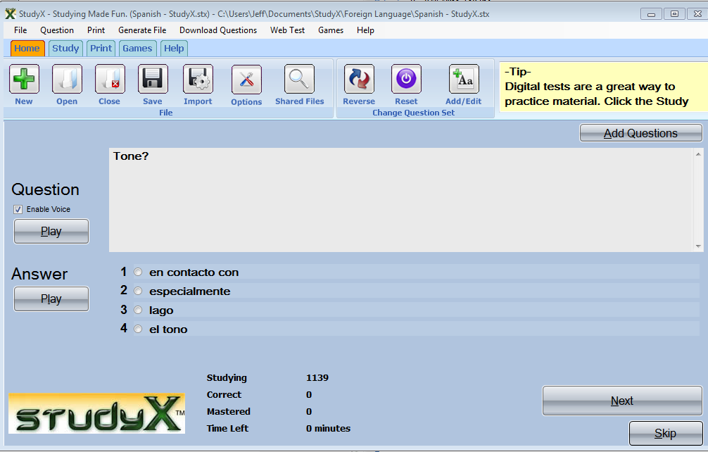 | Select the correct answer.  Then click Next.

Our study software had been designed to handle all of your study needs from note card/flash card printing to study games. Please email us sales@jeffcomputers.com if you have any questions. Notecards/flashcards and other tests are automatically generated by going to Print and then choosing the option. Currently there are 5 major print options.

